Web pages architecture – DP MVC

3ºAno – 1º Semestre

Aulas Teórico-Práticas

laboritory

Docente:

Paulo Torres

Edição revista:

Paulo Torres

**Summary**

1 Design pattern 3

1.1 What is design pattern 3

1.2 MVC design pattern in PHP 3

2 R.D.R and bee project architecture 5

2.1 Controller 5

2.2 Model 6

2.3 View 6



# Design pattern

## What is design pattern

**Design patterns** are typical solutions to commonly occurring problems in software design. They are like pre-made blueprints that you can customize to solve a recurring design problem in your code.

You can’t just find a pattern and copy it into your program, the way you can with off-the-shelf functions or libraries. The pattern is not a specific piece of code, but a general concept for solving a particular problem. You can follow the pattern details and implement a solution that suits the realities of your own program.

Patterns are often confused with algorithms, because both concepts describe typical solutions to some known problems. While an algorithm always defines a clear set of actions that can achieve some goal, a pattern is a more high-level description of a solution. The code of the same pattern applied to two different programs may be different.

An analogy to an algorithm is a cooking recipe: both have clear steps to achieve a goal. On the other hand, a pattern is more like a blueprint: you can see what the result and its features are, but the exact order of implementation is up to you.

## MVC design pattern in PHP

PHP MVC is an application design pattern that separates the application data and business logic (model) from the presentation (view). MVC stands for Model, View & Controller.

The controller mediates between the models and views.

Think of the MVC design pattern as a car and the driver.

The car has the windscreens (view) which the driver (controller) uses to monitor traffic ahead then speed or brake (model) depending on what he sees ahead.

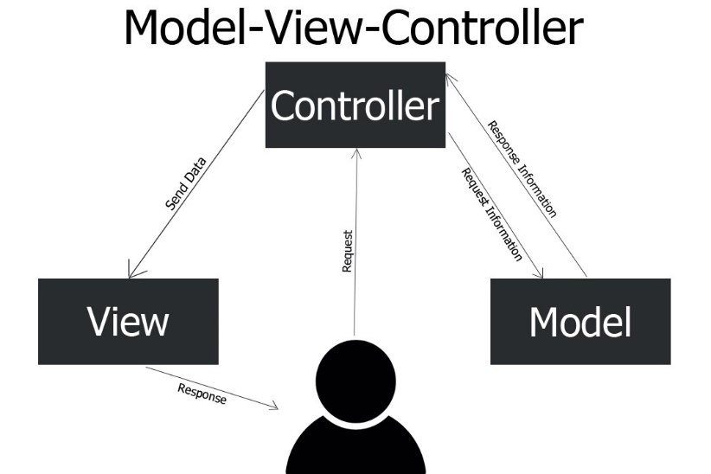

fig 1: explanation of MVC design pattern

Why use PHP MVC Framework?

PHP MVC Frameworks simplify working with complex technologies by:

Hiding all the complex implementation details

Providing standard methods that we can use to build our applications.

Increased developer productivity, this is because the base implementation of activities such as connecting to the database, sanitizing user input etc. are already partially implemented.

Adherence to professional coding standards

Composition of MVC

**Model** – this part is concerned with the business logic and the application data. It can be used to perform data validations, process data and store it. The data can come from;

flat file

database

XML document

Other valid data sources.

**Controller** – this is the part deals with the users’ requests for resources from the server.

As an example, when the user’s requests for the URL *…/index.php?object=list*, the controller will load the products model to retrieve the products data then output the results in the list view.

In a nutshell, the controller links the models and views together depending on the requested resources.

**Views** – this part deals with presenting the data to the user. This is usually in form of HTML pages.

# R.D.R and bee project architecture

In this part, I will explain you the composition of php architecture for R.D.R and bee project website. For simplicity, I will just introduce you that of R.D.R because those are the same.

The architecture is made in this way:

* Config: Contains DB connection and configuration and URL path of the webproject
* Controller: Controller part of the project
* View: View part of the project
* Model: Model part of the project
* Image: Contains all images present in the website

I will explain further the MVC part. First, we will speak about Controller

## Controller

As explain earlier, he mediates between the models and views. In our case, He will receive HTTP POST request by the view and call the model to execute a specific action. In R.D.R, for the table of all objects in the dashboard, we need to receive data in database.

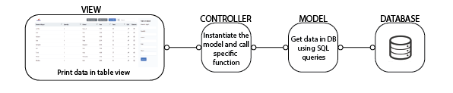

fig 2: explanation of MVC design pattern in RDR project

Controller part is composed of multiple files:

* Index.php: It is used that hub, he receives all the http queries by the view and choose specific action.
* ObjectController.php : He contains all the specific action you can do with object of cars. For example, if you need to receive pieces of cars to print on view, you will develop this functionality of objectController part.

When Index.php receive http request. This request has a specific structure. When view part send request, the structure is this:

<http://website.com/index.php?action=listObjects&name=Wheels>

In this url, first we have the protocol http : http://

Secondary, we have the URL of index.php: website.com/index.php

Finally, you can add more custom action in this url: action=listObjects&name=Wheels

When index file will receive the request, he will going to split the action part (action=””) to know what he need to do. after that he instantiate the specific controller and call function with some parameters. for example, in the query that I introduced you, the query means to call “listObjects” function with the parameter “wheels”. The query permit to receive all the information of wheel object on the database. The function to call the model is in ObectController file because this action is linked at “object” comportment.

## Model

In R.D.R project and Bee project, the Model is used to get or set data in database. After the instantiation of specific model class and the call of function, the model needs to execute the order that asked him. In R.D.R, we have two files in the model:

* ObjectModel.php: Execute queries and return response to controller
* Object.php: Class contains all attributes of Object item

Object class in very special. The only goal of this class is to store all the attributes of object, like this name, this quantity, this year … In the secure way to manipulate object values.

## View

View part is used to the client show all objects data. It’s front part of web development (like the client see). She is composed by:

* JS: it’s javascript, the goal is to execute script in front-side
* CSS: it’s the stylesheet of webpages
* Boostrap: it’s an addon of CSS
* Webpages: it’s like the client see. They contain HTML and a little bit of PHP

In the R.D.R architecture, the client needs to request:

<http://localhost/RDR_template/controller/index.php>

It’s entry point of application. As you see, client need to entry by controller. In fact, the controller will call all the object in the database and return one page of View part. So, the client will see the page of view part with the values catch in Model.